Week 3 Evidence Summary - Greeks and Implied Volatility
Stage Gate 1 · Required by 31 October 2026 · Sanskar
Code: greeks.py, implied_volatility.py · Reproduce with python week3_evidence.py
Repository: https://github.com/Sanskar3584/black-scholes-ml
Contents
1. Finite-difference versus analytic Greeks
2. Error against step size
3. True versus recovered volatility, including low-vega cases
Supporting files

1. Finite-difference versus analytic Greeks
126 parameter combinations: calls and puts, 7 spot levels (70 to 130), 3 maturities (0.25, 1, 2 years), 3 volatilities (15%, 25%, 40%), with $K=100$ and $r=5\%$.
Greek | Max absolute error | Max relative error | Step size $h$
Delta | 1.600e-10 | 1.960e-09 | 1e-04
Gamma | 7.098e-09 | 1.176e-05 | 1e-02
Vega | 5.033e-06 | 2.827e-05 | 1e-04
The step sizes were not chosen arbitrarily. They come from the scan in section 2: a larger $h$ for Gamma because a second difference divides by $h^{2}$ and so suffers worse cancellation.
The analytic Greeks were separately verified against four structural identities over 20,000 random parameter sets - $Δ_{call}−Δ_{put}=e^{−qT}$, equality of Gamma and Vega across calls and puts, and $ν=S^{2}σT Γ$ - all holding at machine precision, and against the Black-Scholes PDE itself with exact derivatives, residual 3.6e-14.

2. Error against step size
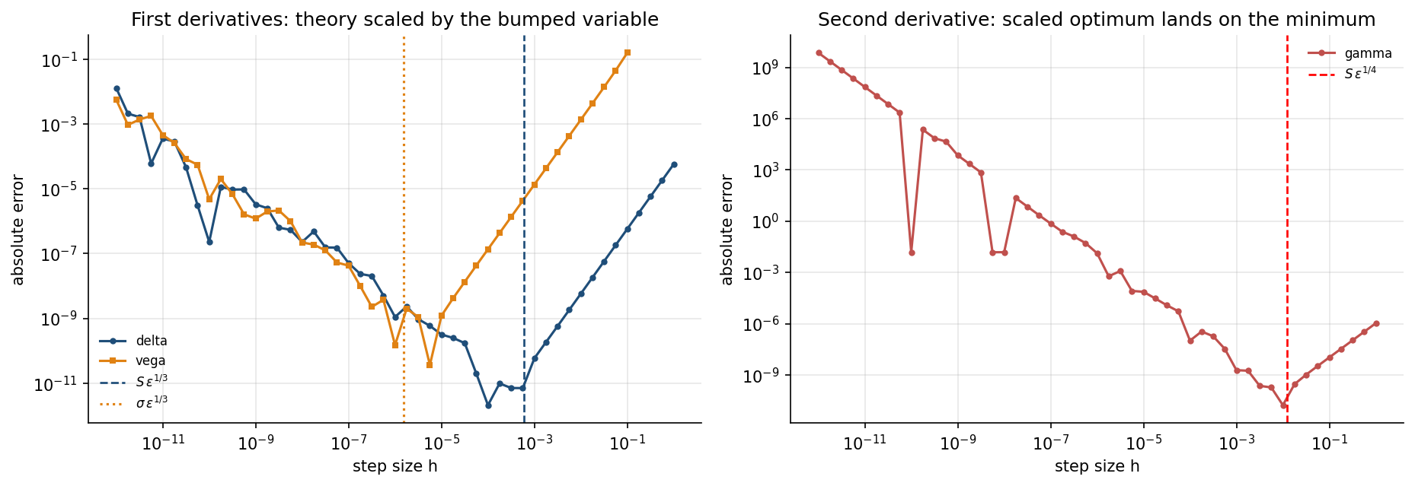
Figure. Absolute error against step size $h$, scanned over twelve orders of magnitude. Left: first derivatives. Right: the second derivative, where cancellation is worse. The dashed reference lines are the theoretical optima scaled by the variable being bumped.
Quantity | Variable bumped | Scaled theoretical optimum | Observed optimum | Ratio | Min error | Error at $h={10}^{−12}$
Delta | $S$ | $Sϵ^{1/3}$ = 6.06e-04 | 1.00e-04 | 0.17 | 2.10e-12 | 1.28e-02
Gamma | $S$ | $Sϵ^{1/4}$ = 1.22e-02 | 1.00e-02 | 0.82 | 1.70e-11 | 7.11e+09
Vega | $σ$ | $σϵ^{1/3}$ = 1.51e-06 | 5.62e-06 | 3.71 | 3.66e-11 | 5.58e-03
Central differences carry truncation error $O(h^{2})$ and round-off error $O(ϵ/h)$, so the total is V-shaped in $h$. The measured truncation-branch slopes are 2.000 (Delta), 2.000 (Gamma), 2.010 (Vega) against a theoretical 2.
On the scaling of the reference lines. $ϵ^{1/3}$ and $ϵ^{1/4}$ are dimensionless, whereas $h$ carries the units of the variable being perturbed. Drawn unscaled, the reference appears to miss the observed optimum by two orders of magnitude. Scaled by that variable - $S$ for Delta and Gamma, $σ$ for Vega - it predicts it: the Gamma reference $Sϵ^{1/4}=0.0122$ sits essentially on the observed optimum of 0.01. Gamma is the sharpest test of the three, because its optimum lies furthest from machine epsilon.
The practical point is the last column. At $h={10}^{−12}$, which looks like a conservative choice, the Gamma error reaches $7×{10}^{9}$ - the computed value bears no relation to the true Gamma of 0.015. A smaller step is not a safer step. This matters directly in November, when the hybrid ML models have no closed-form derivative and finite differences become unavoidable.

3. True versus recovered volatility, including low-vega cases
Prices generated from a known $σ$, then inverted. $K=100$, $r=5\%$, calls.
Case | True $σ$ | BS price | Vega | Recovered $σ$ | Abs error | Iters | Method
ATM, 1 year | 0.25 | 12.335999 | 3.78e+01 | 0.25000000 | 1.4e-16 | 4 | Newton
ATM, 1 year, low vol | 0.10 | 6.804958 | 3.43e+01 | 0.10000000 | 2.2e-16 | 5 | Newton
ATM, 1 year, high vol | 0.60 | 25.523206 | 3.71e+01 | 0.60000000 | 0.0e+00 | 4 | Newton
ITM, 1 year | 0.25 | 27.406343 | 2.75e+01 | 0.25000000 | 7.2e-16 | 6 | Newton
OTM, 1 year | 0.25 | 4.784110 | 3.22e+01 | 0.25000000 | 3.9e-16 | 5 | Newton
ATM, 1 month | 0.25 | 3.018832 | 1.12e+01 | 0.25000000 | 3.3e-16 | 3 | Newton
OTM, 3 months | 0.25 | 1.563092 | 1.42e+01 | 0.25000000 | 5.6e-16 | 5 | Newton
deep OTM, 3 months | 0.25 | 0.009226 | 3.74e-01 | 0.25000000 | 2.8e-16 | 10 | Newton
deep OTM, 1 month | 0.20 | 0.000063 | 5.55e-03 | 0.20000000 | 2.5e-15 | 15 | Newton
deep ITM, 1 month | 0.20 | 30.399203 | 1.97e-04 | 0.20000000 | 1.5e-10 | 19 | Newton
very deep OTM, 1 week | 0.15 | 0.000000 | 1.34e-12 | rejected | - | 0 | -
Recovered 10 of 11. Maximum absolute error 1.52e-10.

Reading the low-vega rows
Accuracy is governed by vega, because $δσ≈\text{residual}/ν$. The effect is visible along the table: the iteration count rises from 4 at $ν≈38$ to 19 at $ν≈2×{10}^{−4}$, and the error rises with it.
The final row is a rejection, not a failure. At $ν=1.3×{10}^{−12}$ the price equals its intrinsic value to within double precision, so no finite $σ$ exists. The solver returns the reason - “price at intrinsic: sigma -> 0, no finite solution” - rather than a fabricated number. This is the behaviour that matters most when real market data arrives: a silently wrong volatility propagates into every model fitted on the surface.

A note on the bisection fallback
On these eleven hand-picked cases the safeguarded Newton iteration succeeded wherever a solution existed, so bisection was invoked zero times. The fallback is not idle: over the 3,000-case random study in the Week 3 report it handled 1.2% of options overall, rising to 28.6% in the lowest vega band. These cases are chosen to span the regimes, not to sample them in proportion.

Supporting files
File | Contents
greeks.py | Analytic Delta, Gamma, Vega, Theta, Rho; self-test over 20,000 sets
implied_volatility.py | Newton with bisection fallback and no-arbitrage bracket checks
week3_evidence.py | Regenerates every number and the figure above
results/w3evidence_fd_errors.csv | All 126 finite-difference comparisons
results/w3evidence_iv_recovery.csv | The recovery table above, with solver diagnostics
greeks_plots/fd_step_size_study.png | The figure above
Full detail is in the Post-Midsem Week 3 report; this summary is deliberately confined to the three items the gate specifies.

